**About the hsb data file**

Most of the examples in this page will use a data file called **hsb2,**high school and beyond.  This data file contains 200 observations from a sample of high school students with demographic information about the students, such as their gender (**female**), socio-economic status (**ses**) and ethnic background (**race**). It also contains a number of scores on standardized tests, including tests of reading (**read**), writing (**write**), mathematics (**math**) and social studies (**socst**). You can get the hsb data file by clicking on [hsb2](https://stats.idre.ucla.edu/wp-content/uploads/2016/02/hsb2-3.sav).

**One sample t-test**

A one sample t-test allows us to test whether a sample mean (of a normally distributed interval variable) significantly differs from a hypothesized value.  For example, using the [hsb2 data file](https://stats.idre.ucla.edu/spss/whatstat/#hsb), say we wish to test whether the average writing score (**write**) differs significantly from 50.  We can do this as shown below.

**t-test**

**/testval = 50**

**/variable = write.**

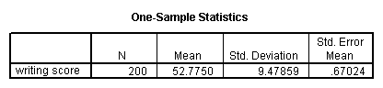

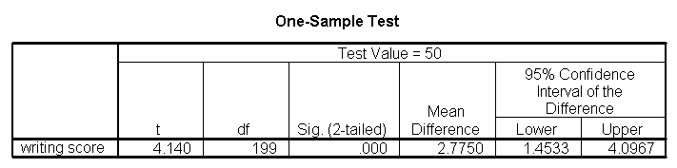

The mean of the variable **write** for this particular sample of students is 52.775, which is statistically significantly different from the test value of 50.  We would conclude that this group of students has a significantly higher mean on the writing test than 50.

**One sample median test**

A one sample median test allows us to test whether a sample median differs significantly from a hypothesized value.  We will use the same variable, **write**, as we did in the [one sample t-test](https://stats.idre.ucla.edu/spss/whatstat/#1sampt) example above, but we do not need to assume that it is interval and normally distributed (we only need to assume that **write** is an ordinal variable).

**nptests**

**/onesample test (write) wilcoxon(testvalue = 50).**

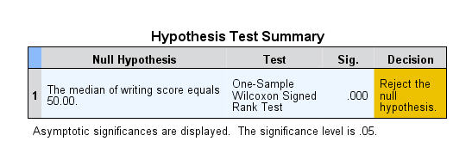

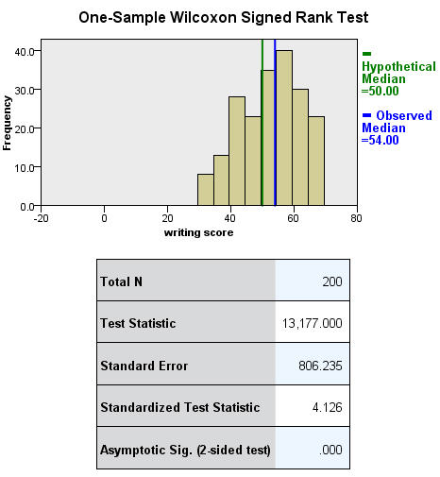

**Binomial test**

A one sample binomial test allows us to test whether the proportion of successes on a two-level categorical dependent variable significantly differs from a hypothesized value.  For example, using the [hsb2 data file](https://stats.idre.ucla.edu/spss/whatstat/#hsb), say we wish to test whether the proportion of females (**female**) differs significantly from 50%, i.e., from .5.  We can do this as shown below.

**npar tests**

**/binomial (.5) = female.**

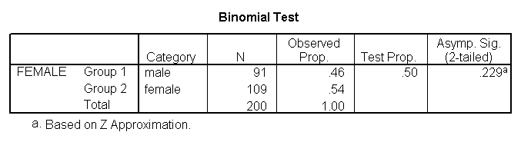

The results indicate that there is no statistically significant difference (p = .229).  In other words, the proportion of females in this sample does not significantly differ from the hypothesized value of 50%.

**Chi-square goodness of fit**

A chi-square goodness of fit test allows us to test whether the observed proportions for a categorical variable differ from hypothesized proportions.  For example, let’s suppose that we believe that the general population consists of 10% Hispanic, 10% Asian, 10% African American and 70% White folks.  We want to test whether the observed proportions from our sample differ significantly from these hypothesized proportions.

**npar test**

**/chisquare = race**

**/expected = 10 10 10 70.**

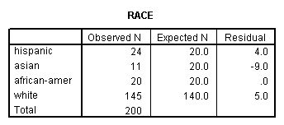

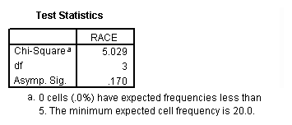

These results show that racial composition in our sample does not differ significantly from the hypothesized values that we supplied (chi-square with three degrees of freedom = 5.029, p = .170).

**Two independent samples t-test**

An independent samples t-test is used when you want to compare the means of a normally distributed interval dependent variable for two independent groups.  For example, using the [hsb2 data file](https://stats.idre.ucla.edu/spss/whatstat/#hsb), say we wish to test whether the mean for **write** is the same for males and females.

**t-test groups = female(0 1)**

**/variables = write.**

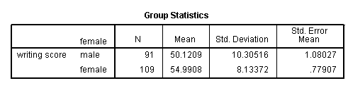

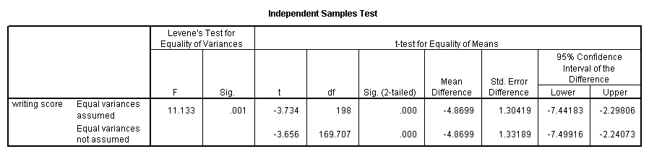

Because the standard deviations for the two groups are similar (10.3 and 8.1), we will use the “equal variances assumed” test.  The results indicate that there is a statistically significant difference between the mean writing score for males and females (t = -3.734, p = .000).  In other words, females have a statistically significantly higher mean score on writing (54.99) than males (50.12).

**See also**

* [SPSS Learning Module: An overview of statistical tests in SPSS](https://stats.idre.ucla.edu/spss/modules/an-overview-of-statistical-tests-in-spss/)

**Wilcoxon-Mann-Whitney test**

The Wilcoxon-Mann-Whitney test is a non-parametric analog to the independent samples t-test and can be used when you do not assume that the dependent variable is a normally distributed interval variable (you only assume that the variable is at least ordinal).  You will notice that the SPSS syntax for the Wilcoxon-Mann-Whitney test is almost identical to that of the independent samples t-test.  We will use the same data file (the [hsb2 data file](https://stats.idre.ucla.edu/spss/whatstat/#hsb)) and the same variables in this example as we did in the [independent t-test example](https://stats.idre.ucla.edu/spss/whatstat/#2ittest) above and will not assume that **write**, our dependent variable, is normally distributed.

**npar test**

**/m-w = write by female(0 1).**

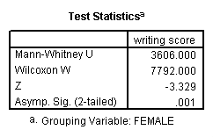

The results suggest that there is a statistically significant difference between the underlying distributions of the **write** scores of males and the **write** scores of females (z = -3.329, p = 0.001).

**See also**

* [FAQ: Why is the Mann-Whitney significant when the medians are equal?](https://stats.idre.ucla.edu/other/mult-pkg/faq/general/faq-why-is-the-mann-whitney-significant-when-the-medians-are-equal/)

**Chi-square test**

A chi-square test is used when you want to see if there is a relationship between two categorical variables.  In SPSS, the **chisq**option is used on the **statistics** subcommand of the **crosstabs** command to obtain the test statistic and its associated p-value.  Using the [hsb2 data file](https://stats.idre.ucla.edu/spss/whatstat/#hsb), let’s see if there is a relationship between the type of school attended (**schtyp**) and students’ gender (**female**).  Remember that the chi-square test assumes that the expected value for each cell is five or higher. This assumption is easily met in the examples below.  However, if this assumption is not met in your data, please see the section on Fisher’s exact test below.

**crosstabs**

**/tables = schtyp by female**

**/statistic = chisq.**

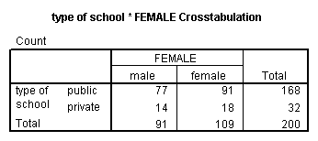

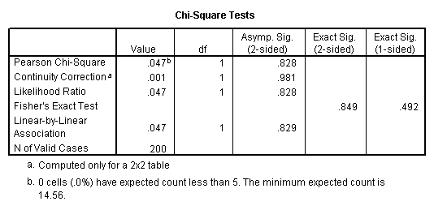

These results indicate that there is no statistically significant relationship between the type of school attended and gender (chi-square with one degree of freedom = 0.047, p = 0.828).

Let’s look at another example, this time looking at the linear relationship between gender (**female**) and socio-economic status (**ses**).  The point of this example is that one (or both) variables may have more than two levels, and that the variables do not have to have the same number of levels.  In this example, **female** has two levels (male and female) and **ses** has three levels (low, medium and high).

**crosstabs**

**/tables = female by ses**

**/statistic = chisq.**

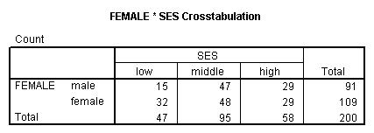

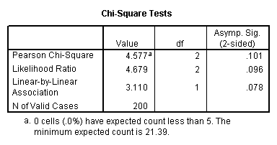

Again we find that there is no statistically significant relationship between the variables (chi-square with two degrees of freedom = 4.577, p = 0.101).

**See also**

* [SPSS Learning Module: An Overview of Statistical Tests in SPSS](https://stats.idre.ucla.edu/spss/modules/an-overview-of-statistical-tests-in-spss/)

**Fisher’s exact test**

The Fisher’s exact test is used when you want to conduct a chi-square test but one or more of your cells has an expected frequency of five or less.  Remember that the chi-square test assumes that each cell has an expected frequency of five or more, but the Fisher’s exact test has no such assumption and can be used regardless of how small the expected frequency is. In SPSS unless you have the SPSS Exact Test Module, you can only perform a Fisher’s exact test on a 2×2 table, and these results are presented by default.  Please see the results from the chi squared example above.

**One-way ANOVA**

A one-way analysis of variance (ANOVA) is used when you have a categorical independent variable (with two or more categories) and a normally distributed interval dependent variable and you wish to test for differences in the means of the dependent variable broken down by the levels of the independent variable.  For example, using the [hsb2 data file](https://stats.idre.ucla.edu/spss/whatstat/#hsb), say we wish to test whether the mean of **write** differs between the three program types (**prog**).  The command for this test would be:

**oneway write by prog.**

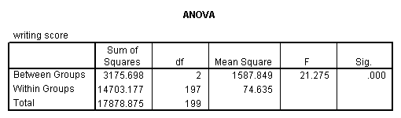

The mean of the dependent variable differs significantly among the levels of program type.  However, we do not know if the difference is between only two of the levels or all three of the levels.  (The F test for the **Model** is the same as the F test for **prog**because **prog** was the only variable entered into the model.  If other variables had also been entered, the F test for the **Model**would have been different from **prog**.)  To see the mean of **write** for each level of program type,

**means tables = write by prog.**

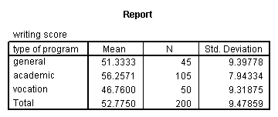

From this we can see that the students in the academic program have the highest mean writing score, while students in the vocational program have the lowest.

**See also**

* [SPSS Textbook Examples: Design and Analysis, Chapter 7](https://stats.idre.ucla.edu/spss/examples/da/design-analysis-by-keppelchapter-7/)
* [SPSS Textbook Examples: Applied Regression Analysis, Chapter 8](https://stats.idre.ucla.edu/spss/examples/ara/applied-regression-analysis-by-john-fox-chapter-8-analysis-ofvariance/)
* [SPSS FAQ: How can I do ANOVA contrasts in SPSS?](https://stats.idre.ucla.edu/spss/faq/how-can-i-do-anova-contrasts-in-spss/)
* [SPSS Library: Understanding and Interpreting Parameter Estimates in Regression and ANOVA](https://stats.idre.ucla.edu/spss/library/spss-libraryunderstanding-and-interpreting-parameter-estimates-in-regression-and-anova/)

**Kruskal Wallis test**

The Kruskal Wallis test is used when you have one independent variable with two or more levels and an ordinal dependent variable. In other words, it is the non-parametric version of ANOVA and a generalized form of the Mann-Whitney test method since it permits two or more groups.  We will use the same data file as the [one way ANOVA example](https://stats.idre.ucla.edu/spss/whatstat/#1anova) above (the [hsb2 data file](https://stats.idre.ucla.edu/spss/whatstat/#hsb)) and the same variables as in the example above, but we will not assume that **write** is a normally distributed interval variable.

**npar tests**

**/k-w = write by prog (1,3).**

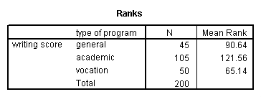

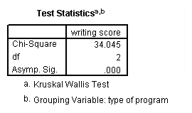

If some of the scores receive tied ranks, then a correction factor is used, yielding a slightly different value of chi-squared.  With or without ties, the results indicate that there is a statistically significant difference among the three type of programs.

**Paired t-test**

A paired (samples) t-test is used when you have two related observations (i.e., two observations per subject) and you want to see if the means on these two normally distributed interval variables differ from one another.  For example, using the [hsb2 data file](https://stats.idre.ucla.edu/spss/whatstat/#hsb) we will test whether the mean of **read** is equal to the mean of **write**.

**t-test pairs = read with write (paired).**

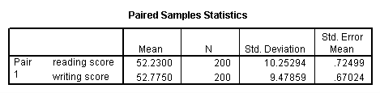

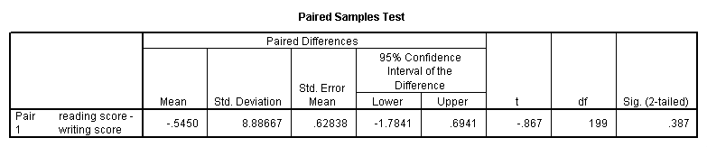

These results indicate that the mean of **read** is not statistically significantly different from the mean of **write** (t = -0.867, p = 0.387).

**Wilcoxon signed rank sum test**

The Wilcoxon signed rank sum test is the non-parametric version of a paired samples t-test.  You use the Wilcoxon signed rank sum test when you do not wish to assume that the difference between the two variables is interval and normally distributed (but you do assume the difference is ordinal). We will use the same example as above, but we will not assume that the difference between **read** and **write** is interval and normally distributed.

**npar test**

**/wilcoxon = write with read (paired).**

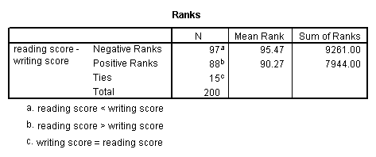

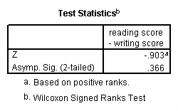

The results suggest that there is not a statistically significant difference between **read** and **write**.

If you believe the differences between **read** and **write** were not ordinal but could merely be classified as positive and negative, then you may want to consider a sign test in lieu of sign rank test.  Again, we will use the same variables in this example and assume that this difference is not ordinal.

**npar test**

**/sign = read with write (paired).**

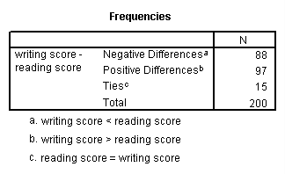

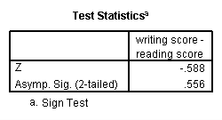

We conclude that no statistically significant difference was found (p=.556).

**McNemar test**

You would perform McNemar’s test if you were interested in the marginal frequencies of two binary outcomes. These binary outcomes may be the same outcome variable on matched pairs (like a case-control study) or two outcome variables from a single group.  Continuing with the hsb2 dataset used in several above examples, let us create two binary outcomes in our dataset: **himath** and **hiread**. These outcomes can be considered in a two-way contingency table.  The null hypothesis is that the proportion of students in the **himath** group is the same as the proportion of students in **hiread** group (i.e., that the contingency table is symmetric).

**compute himath = (math>60).**

**compute hiread = (read>60).**

**execute.**

**crosstabs**

**/tables=himath BY hiread**

**/statistic=mcnemar**

**/cells=count.**

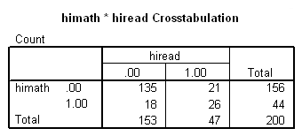

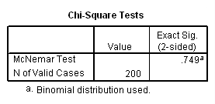

McNemar’s chi-square statistic suggests that there is not a statistically significant difference in the proportion of students in the **himath** group and the proportion of students in the **hiread** group.